Crop and Fertilizer Recommendation Using Machine Learning

Abstract—Selecting the appropriate crop and fertilizer for a season can be some of the most difficult choices for farmers to make. Choosing incorrectly can lead to decreased yields, increased costs of growing crops and soil degradation. This paper outlines a Machine Learning based Crop and Fertilizer Recommendation System. This system gives the user a single application which will provide them with the ideal crop and fertilizer. The crop recommendation takes into account nitrogen, phosphorus, potassium, temperature, humidity, soil pH and rainfall to predict a suitable crop. The fertilizer recommendation takes into account temperature, humidity, moisture, soil type, crop type, nitrogen, phosphorus and potassium. To predict the crop several models were considered including Decision Tree, K-Nearest Neighbors, Naive Bayes, Random Forest and XGBoost. The crop prediction model used in the application was Random Forest. For the fertilizer recommendation the Random Forest model was also used. The application was created using Python and features a Streamlit interface. This allows the user to simply input the values and receive an output. The application was tested with various inputs and we have noted our observations. Accuracy figures have not been recorded. The recommendations provided should be seen as a tool to help with decision making. It should not be considered as a replacement for soil testing or expert advice..
Index Terms—Machine Learning, Smart Agriculture, Crop
Recommendation, Fertilizer Recommendation, Random Forest,
Streamlit

I. INTRODUCTION
Agriculture feeds a large part of the world’s population and, in India, it remains one of the main pillars of the economy and of rural livelihoods. Every season a farmer has to make a series of decisions: which crop to grow on a
given piece of land, how much attention the soil needs, and which fertilizer to apply. These decisions are closely linked. A crop that suits the soil and climate of a field will usually give a better return than one that does not, and a fertilizer that matches the nutrient needs of that crop will do more good than a random choice.
Crop suitability depends on the nutrient content of the soil, mainly nitrogen (N), phosphorus (P) and potassium (K), on soil pH, and on climate factors such as temperature, humidity and rainfall [1]. Fertilizer choice depends on the nutrients already present, the moisture in the soil, the soil type and the crop being grown. When these factors are ignored, two kinds of loss follow. If the crop does not suit the conditions, the yield falls. If fertilizer is applied in excess or without need, money is wasted and the surplus can pollute the environment.
Traditionally, many of these choices rest on experience and on general advice. Experience is valuable, but it is not always backed by accurate soil data, and the weather and soil can differ a lot even between nearby regions. A datadriven approach can add consistency here, because it looks at the actual measured values instead of relying on memory or habit alone.
Machine learning is well suited to this kind of problem. A classification algorithm can be trained on earlier agricultural records, learn the pattern that links soil and weather values to the crop or fertilizer that suited them, and then apply that pattern to new values entered by a user [5], [6]. Such a model does not understand farming, but it can pick up relationships in the data that are hard to write down as fixed rules.
In this work we built a single application that covers two tasks: crop recommendation and fertilizer recommendation. The main objectives are:
- to analyse soil and climate parameters and recommend a crop that suits them;
- to recommend a fertilizer category using soil nutrients, moisture, soil type and crop type;
- to help reduce wasted fertilizer and unnecessary cost through better-informed choices; and
- to offer a simple, interactive interface that does not need any knowledge of machine learning.
Problem statement. Given a set of soil and climate measurements, the task is to predict (a) the crop that best suits those conditions and (b) the fertilizer that best suits a given soil and crop combination, using models learned from agricultural data, and to deliver both answers through an interface that any farmer or advisor can use.
We want to be clear about the purpose of the tool. It is not meant to replace agricultural experts or soil testing laboratories. It is a decision-support aid that gives a quick, data-based suggestion which the user can then check against local advice.
The rest of the paper is organised as follows. Section II reviews related work and states the research gap. Section III explains the overall methodology, and Section IV describes data preprocessing. Sections V and VI present the crop and fertilizer modules. Section VII gives the system architecture and Section VIII describes the implementation. Section IX reports testing and evaluation, Section X lists the benefits and applications, and Section XI discusses the limitations. Sections XII and XIII give the conclusion and future scope.

II. LITERATURE SURVEY
A fair amount of research has looked at how machine learning can support farming decisions. The common idea in these studies is that soil nutrients and climate readings can be used as input features, and that a trained classifier can map them to a suitable crop or fertilizer. We looked at four recent studies that are close to our topic.
Dey et al. [1] studied machine learning based recommendation of agricultural and horticultural crops in India, using NPK values, soil pH and climatic variables as inputs. Their work shows that these same kinds of parameters can be used effectively to recommend crops, which is the basis of our crop module.
Govindwar et al. [2] presented a system that recommends both crops and fertilizers using machine learning. The significance of their study for us is the idea of putting the two recommendations side by side, so that one tool supports the planning of cultivation as a whole.
Tanaka et al. [3] raised a more cautious question: can machine learning models really give accurate fertilizer recommendations? Their study stresses how much depends on good agricultural data and on careful evaluation of the model. We took this as a reminder not to claim more than our own testing supports.
Prity et al. [4] followed a machine learning approach to crop recommendation and showed how data-driven methods can be used to improve agricultural productivity.
On the algorithm side, Decision Tree, K-Nearest Neighbors (KNN), Naive Bayes and Random Forest are all standard classifiers and have been used widely across many fields [5], [7]. Random Forest [9] is an ensemble method that builds many decision trees and combines their votes, which usually makes it more stable than a single tree. XGBoost [10] is another ensemble method, in which trees are added one after another so that each new tree corrects the errors of the earlier ones.
Table I places these studies next to the system proposed in this paper, using only the focus of each work as described above.

TABLE I
RELATED STUDIES COMPARED WITH THE PROPOSED SYSTEM
Study | Main focus | Crop and  fertilizer together
Dey et al. [1] | Crop recommendation using NPK, pH and climate | No
Govindwar et al. [2] | Crop and fertilizer recommendation | Yes
Tanaka et al. [3] | Accuracy of fertilizer recommendation models | No
Prity et al. [4] | Crop recommendation to raise productivity | No
Proposed system | Both tasks in one Streamlit application with Random Forest | Yes

A. Research Gap
The studies above show that machine learning is useful in agriculture, but a practical tool still has to deal with several issues:
- Many systems deal with only one task, crop recommendation or fertilizer recommendation, although a farmer usually needs both while planning a season.
- Soil and climate change from one region to another, so a model trained on one dataset may not work equally well elsewhere.
- Some tools are hard to use. A complicated interface makes it difficult to enter values and understand the result.
- The quality and availability of agricultural data directly affect how useful the predictions are.
To address these points, our system keeps both recommendations in one Streamlit application, uses a small set of easily available input values, and shows the output in a simple form.

III. PROPOSED METHODOLOGY
The methodology follows the usual sequence of a supervised learning project. Agricultural data is collected, cleaned and arranged, models are trained on it, and the trained models are then used to make predictions for new inputs that a user enters. The overall workflow is shown in Fig. 1.
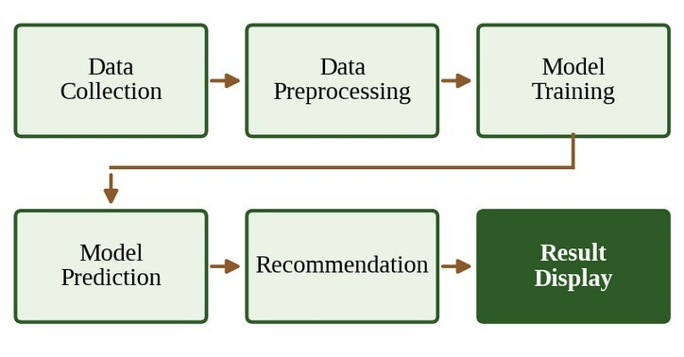
Fig. 1. Overall workflow of the proposed system.
The project is divided into two modules that share this workflow: a crop recommendation module and a fertilizer recommendation module. Each has its own input features and its own target to predict.

A. Data Collection
Agricultural datasets are used to train the models. Each record contains a set of soil and environmental measurements together with the label that the model has to learn. For crop recommendation the features are nitrogen, phosphorus, potassium, temperature, humidity, soil pH and rainfall, and the label is the crop. For fertilizer recommendation the features are temperature, humidity, moisture, soil type, crop type, nitrogen, phosphorus and potassium, and the label is the fertilizer. Table II summarises both tasks.
TABLE II
SUMMARY OF THE TWO RECOMMENDATION TASKS
Item | Crop module | Fertilizer module
Task type | Classification | Classification
Numeric inputs | N, P, K, temperature, humidity, pH, rainfall | N, P, K, temperature, humidity, moisture
Categorical inputs | None | Soil type, crop type
Target | Crop | Fertilizer
Model in app | Random Forest | Random Forest

B. Data Flow During Training and Prediction
Historical data will be cleaned and provided to the learning algorithm. This will train a model which will then be evaluated. When making a prediction the data entered by the user will be cleaned in the same way and provided to the saved model. It is important that the data flows are consistent.
Behind this there are five stages to the process. First historical data is collected. Then it is cleaned. The model is trained using this data. Recommendations are made using the trained model. Finally the recommendations are evaluated. This is important to ensure that if the results aren’t great the data/model can be adjusted.

IV. DATA PREPROCESSING
Raw data cannot be provided directly to the learning algorithm. It needs to be checked and formatted. For our project the preprocessing includes:
• Data checking. Ensuring that the columns match the inputs.
• Preparing inputs. Splitting the selected columns from the label.
• Categoricals. The soil type and crop type in the fertilizer module are words. They need to be converted into numerical values to be processed by the Random Forest model.
• Ordering. Ensuring the features are in the same order as when the model was trained.
This can often be overlooked. Models will be trained based on a fixed column structure. It is only reliable if the new data is in the same format and encoding. For the crop module all inputs are numerical so the main thing to focus on is ordering them. For the fertilizer module the categoricals need to be in the same format at training and prediction.
V. CROP RECOMMENDATION
This is a classification problem. The application takes the soil and climate data (Table III) and predicts one crop category.

TABLE III
INPUTS OF THE CROP RECOMMENDATION MODULE
Input | Meaning | Interface control
N | Nitrogen content of the soil | Number field
P | Phosphorus content of the soil | Number field
K | Potassium content of the soil | Number field
Temperature | Air temperature (°C) | Slider, 0–50
Humidity | Relative humidity (%) | Slider, 0–100
pH | Acidity or alkalinity of the soil | Slider, 0–14
Rainfall | Rainfall (mm) | Number field

A. Input Parameters
Each input provides different information. The first three inputs describe the primary nutrients present in the soil. Different crops require different proportions of these nutrients for optimal growth. The pH value indicates how easily plant roots can absorb the available nutrients. Temperature, humidity, and rainfall provide information about the climatic conditions affecting crop cultivation. While each factor alone offers limited insight, their combined analysis helps determine the overall growing conditions of the field. This is the information that the classifier learns to make predictions.
Five algorithms were considered for this module. The files containing the trained models have been included. A brief explanation of how each algorithm works is presented in Table IV.

TABLE IV
ALGORITHMS CONSIDERED FOR CROP RECOMMENDATION
Algorithm | Basic idea | Point to note
Decision Tree | Asks a series of yes/no questions  on the features until it reaches a crop | Easy to follow but can overfit
KNN | Finds the most similar past records and takes the majority crop | Needs distance  calculation for every query
Naive Bayes | Uses probabilities and assumes features are independent | Fast, but the independence assumption is strict
Random  Forest | Many trees vote on the crop | More stable than a single tree
XGBoost | Trees are built one after another, each fixing earlier errors | Powerful but has more settings to tune
The first three algorithms in Table IV can be written compactly. A decision tree chooses its splits so as to reduce the Gini impurity of a node,
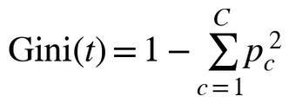 (1)
where p_{c} is the fraction of records of class c in node t and C is the number of classes. KNN measures how close a new input x is to a stored record x′ with the Euclidean distance
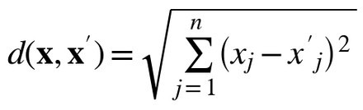 (2)
over the n input features, and the crop is taken from the k closest records. Naive Bayes picks the class with the largest posterior probability under the independence assumption,
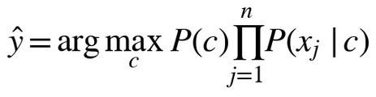 (3)
and XGBoost forms its prediction by adding the outputs of
K trees f_{k},
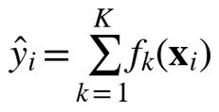 (4)
Each new tree is fit to correct errors made previously [10].
The inputs for this task are numerical and are on very different scales. For example rainfall is in the hundreds whilst pH is single digits. This can cause issues with distance based algorithms like KNN but tree based algorithms are unaffected.
C. Random Forest in the Application
The application uses Random Forest to predict the crop. Random Forest is an ensemble method. It doesn’t trust one decision tree so creates many trees using slightly different samples from the training data. Each tree will produce a prediction. For classification the final answer will be the most common class (Fig. 2) [9].
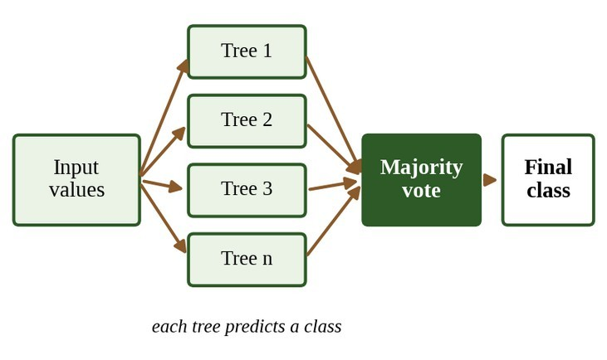
Fig. 2. Working of Random Forest: many trees vote and the majority class is returned.
If T trees are created then the forest will return the most common class.,
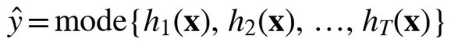 (5)
and the share of trees voting for a class c can be read as a rough confidence for that class:
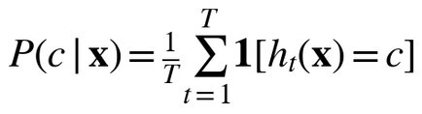 (6)
This is a good fit for our problem. Firstly there is no linear relationship between the soil/climate data and best crop. Many factors will be involved and trees can account for this. Secondly the final answer is based on many trees so it won’t be decided by an odd tree. When inputs are entered by the user they are sent to the trained forest and the crop most trees agree on will be returned. The flow can be seen in fig. 3.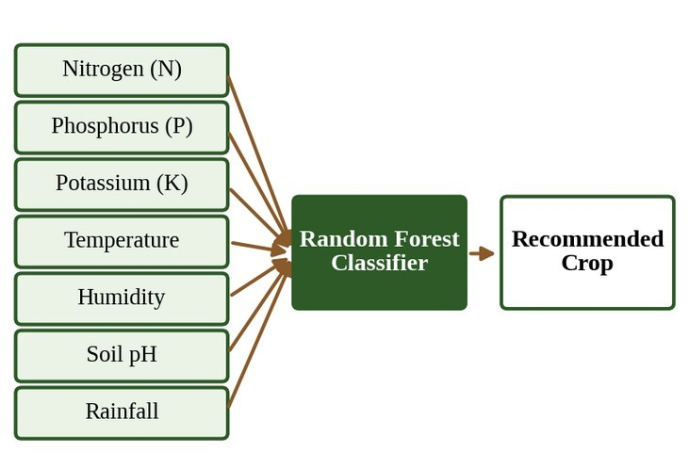
Fig. 3. Crop recommendation module: seven inputs go to the Random Forest classifier.

We have not ranked the five algorithms based on accuracy in this paper. We would like this to be based on proper evaluation.VI. FERTILIZER RECOMMENDATION MODULE
The This module predicts a fertilizer category based on the soil and crop data. The inputs are shown in table V.

TABLE V
INPUTS OF THE FERTILIZER RECOMMENDATION MODULE
Input | Meaning | Interface control
Temperature | Air temperature (°C) | Slider, 10–50
Humidity | Relative humidity (%) | Slider, 0–100
Moisture | Soil moisture (%) | Slider, 0–100
Soil type | Category of soil | Drop-down list
Crop type | Crop being grown | Drop-down list
N, P, K | Nutrients present in the soil | Number fields
There are several reasons for these inputs. The nutrients will tell the model what is already present in the soil. This means the recommended fertilizer will fill in any gaps. The moisture will tell us how well the nutrients will dissolve and reach the roots. The soil type will affect how much water and nutrients are held in the ground. The crop type will determine what nutrients are in high demand. Temperature and humidity finish off describing the environment.
This module differs from the crop module as there are numerical inputs and two categorical inputs (soil type and crop type). The categorical inputs are encoded before going to the classifier (fig. 4). The crop is also an input meaning the fertilizer will be recommended for a specific crop.
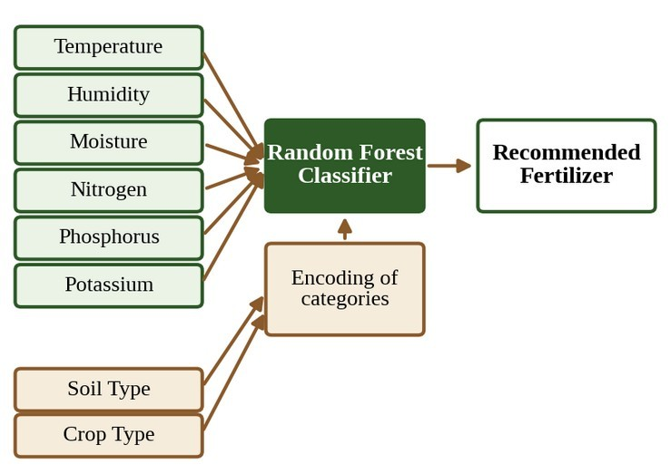
Fig. 4. Fertilizer recommendation module: numeric and encoded categorical inputs feed a Random Forest.
A Random Forest classifier is used to make an accurate prediction. The Random Forest algorithm is trained to understand how the nutrients, moisture, soil type and crop relate to the fertilizer applied. When used, the application will run the provided values, pass them through the trained model and show the predicted fertilizer on the Streamlit page. This provides a data driven basis for choosing the correct fertilizer.
Currently, the fertilizer module only provides an appropriate category. How much and when to apply is dependent on verified agricultural guidelines and soil test results. This is listed as future work.

Vii SYSTEM ARCHITECTURE
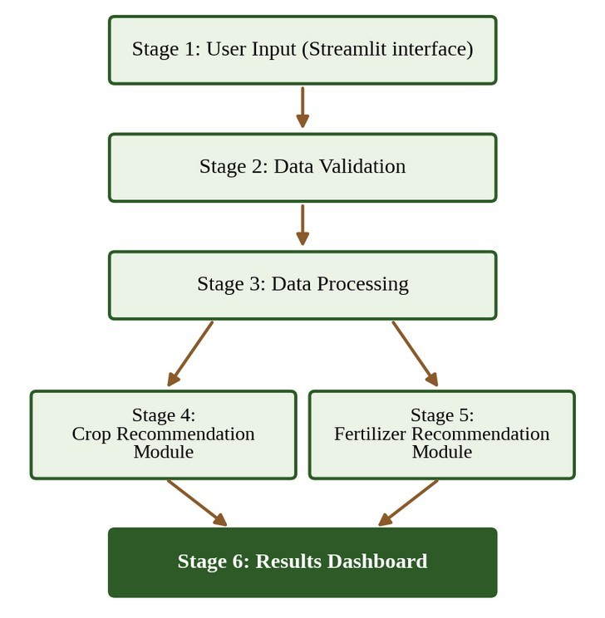
Fig. 5. Six-stage system architecture.
The The system is broken down into 6 stages, as seen in Fig. 5. The user interacts with the Streamlit application, choosing the correct module and entering the values. These values are validated, formatted and passed into the correct module (crop or fertilizer). The relevant Random Forest model will make a prediction and this will be displayed on the dashboard
.VIII IMPLEMENTATION
The system is implemented in Python. The libraries used and their roles are given in Table VI.

TABLE VI
TECHNOLOGIES USED
Technology | Purpose
Python | Main programming language
Pandas | Data handling and preprocessing
NumPy | Numerical operations
Scikit-learn | Machine learning algorithms [8]
Streamlit | Web application interface
Pickle | Saving and loading trained models
The models are trained once. They are saved using Pickle. When the application opens, the models are loaded. This means that the models do not need to be trained again. The crop module has been saved with Decision Tree, KNN, Naive Bayes, Random Forest and XGBoost models. The application will use the Random Forest model. The fertilizer module has its own saved Random Forest model.
Streamlit is used to connect the models to the user. The user will select the correct module (crop or fertilizer). They will enter their data and press the button. Streamlit will display the recommended crop/fertilizer. The interface is a web page, so when the application is hosted no additional software needs to be installed.
The user will simply follow 4 easy steps:
Select whether you want to receive a crop recommendation or fertilizer recommendation.

Enter your soil and weather data.
Click the button to validate and format the data.
View the recommended crop/fertilizer.
IX. RESULTS AND EVALUATION
A. Application Interface
The system was ran as a Streamlit application. Multiple combinations of data were tried. The crop module (Fig. 6) has a short description, followed by 2 sections of data. The first section will ask for the soil nutrients, N, P and K will be entered. The second section will ask for temperature (0-50° C), humidity (0-100%) and soil pH (0- 14) via sliders. Rainfall (mm) will be entered. There is a single button to run the model.
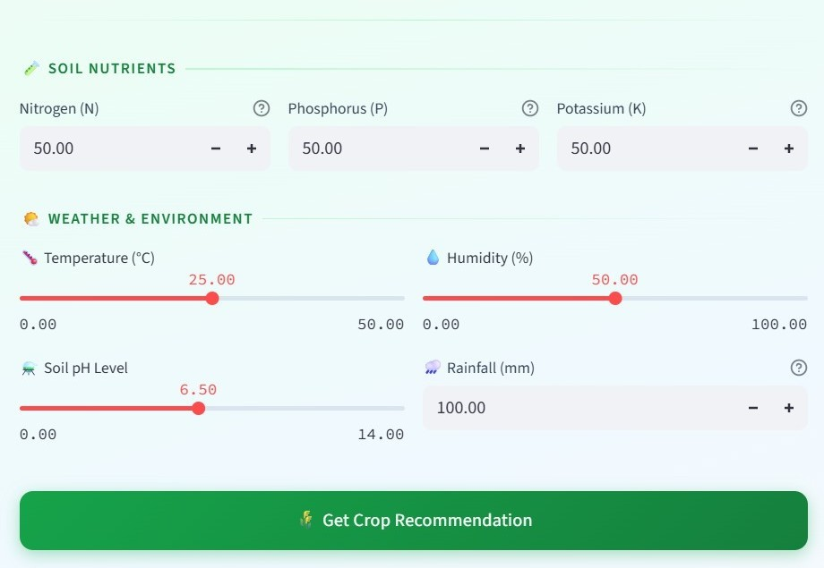
Fig. 6. Crop recommendation interface with soil nutrient and weather inputs.

The fertilizer module (Fig. 8) has input boxes for N/P/K. Temperature (10-50° C), humidity and soil moisture (0-100%) will be selected via sliders. Soil type and crop type will be selected via dropdowns. There is a button to recommend the fertilizer.

B. Test Cases

Below is a table showing the 4 test cases run. 2 for each module. The output is displayed.

TABLE VII
TEST CASES AND OUTPUTS OF THE APPLICATION
Test | Input values | Output
Crop 1 | N 50, P 50, K 50, temperature 25 °C, humidity 50 %, pH 6.5, rainfall 100 mm | Mango
Crop 2 | N 35, P 72, K 49, temperature 17.5 °C, humidity 60.5 %, pH 5.0, rainfall 50 mm | Lentil
Fert. 1 | N 90, P 40, K 41, temperature 25 °C, humidity 70 %, moisture 30 %, loamy soil, barley | DAP
Fert. 2 | N 50, P 50, K 40, temperature 25 °C,  humidity 55 %, moisture 40 %, clay soil, paddy | Urea

C. Output Analysis
When running the crop module the application displayed Mango and Lentil (Fig. 7). Each has a short description stating which type of soil the crop grows well in. The second set of data has many differences in the data, including lower temperature, less rainfall and more acidic soil. The nutrient levels are also different.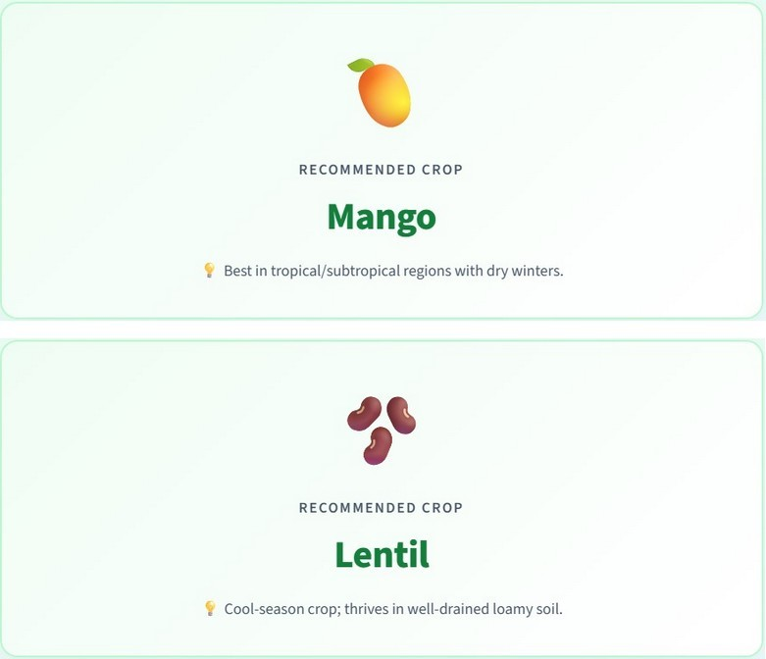
Fig. 7. Crop recommendation outputs for test cases Crop 1 (Mango) and Crop 2 (Lentil).
When running the fertilizer module, the application displayed DAP for the loamy soil barley and Urea for the clay soil paddy (Fig. 8 & 9). This shows that the model reacts to the changes in nutrient levels, soil type and crop type..
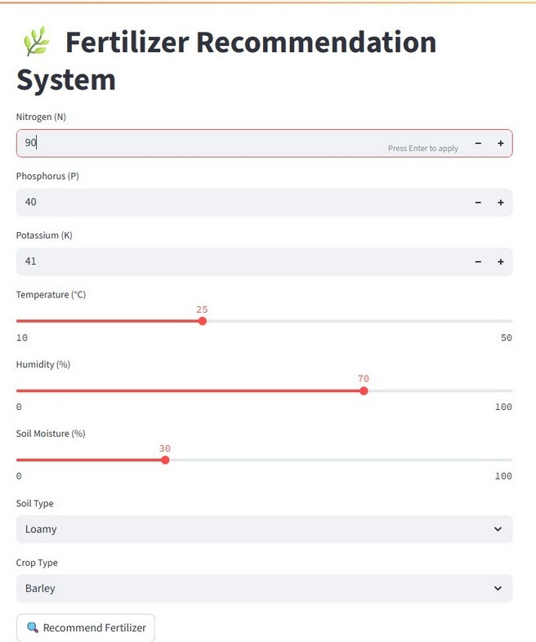
Fig. 8. Fertilizer recommendation interface (inputs of test case Fert. 1).
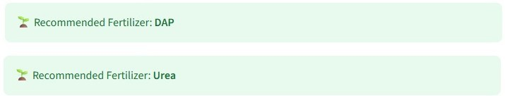
Fig. 9. Fertilizer outputs: DAP (Fert. 1) and Urea (Fert. 2).

This shows that the application is working. The output varies depending on the input. Although this shows that the application is working, it does not prove that it provides the best recommendation. This can be checked by consulting experts and evaluating the models.

D. Evaluation Metrics
Accuracy percentages will not be mentioned in this paper due to no evaluation being performed yet. When evaluating a classifier such as this, some data will be held out. This data will be predicted and the results will be compared to actual data. Given C classes and N test data, True Positives (TPc), False Positives (FPc) and False Negatives (FNc) can be calculated. Overall accuracy can be calculated using: 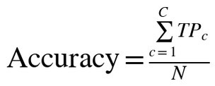 (7)
and the precision and recall of each class are
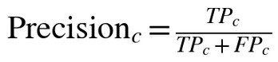
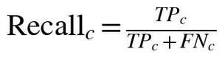
(8)
(9) P Precision shows how many of the data that were predicted to be class c actually are class c. Recall shows how many true members of class c were found. F1-Score provides a balance between the two.
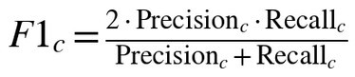 (10)
As there are many different crops, each class will have a score and they will be averaged to give a single value. 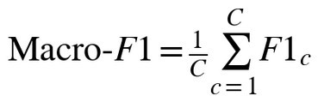 (11)
A confusion matrix will show which crops/fertilizers are being confused. Using these metrics to evaluate all 5 crop algorithms will provide a fair comparison. Splitting the data multiple times (e.g. Cross Validation) will show if the scores are consistent.
X. BENEFITS AND APPLICATIONS
Based on how the system works, the following benefits can be seen:
Choose informed crops. The crop will be chosen based on the soil and climate data.
Use more information from the soil. The soil test data will be used to provide a recommendation.
Reduce farming costs. Choosing an appropriate fertilizer will reduce waste and unnecessary costs.
Ensure healthy soil. Overuse of fertilizer can be avoided.
This concept can be applied to many different areas. This could include precision agriculture, soil testing advice, digital farming tools and agricultural extension services.
XI. DISCUSSION
The main benefit of this system is that the user will have 2 related decisions in one place. The crop module takes into account multiple soil and climate factors. The fertilizer module takes into account nutrient levels, crop type and soil type. The interface is also very simple. The user enters their data and receives their answer.
The tool should be used as a recommendation. The user will always have control. The system will give a recommendation, but the farmer or advisor will decide based on their knowledge. Therefore the model gives a second opinion.
There are also limitations to this system.
Relies on data. The model is only as good as the data it has been trained on. If the data is incomplete or unbalanced, this can limit how accurate the predictions are [3].
Variations in data. Soil/climate will vary depending on the region, season and soil type. This can mean the model will not be suitable for all real life fields.
Weather changes over time. The weather patterns will change overtime, meaning the model will gradually become less accurate if not updated.
Does not provide quantities/timing. The fertilizer module does not provide the quantities or timing of the fertilizer.
Therefore the output should be taken as a recommendation. Farmers should still consider the soil test results, local weather and agricultural experts.
XII. CONCLUSION
We have created a Crop and Fertilizer Recommendation System. This uses machine learning to assist in farming decisions. The crop module will predict an appropriate crop based on the N, P, K, Temperature, Humidity, pH and Rainfall. The fertilizer module will recommend an appropriate fertilizer based on the Temperature, Humidity, Moisture, Soil Type, Crop Type and the 3 nutrients. Multiple algorithms have been considered for the crop prediction. The application uses the Random Forest algorithm for both modules. The system has been created in Python, with Streamlit. This provides the user with an easy to use interface.
This has shown that machine learning can be a useful tool for aiding decisions in agriculture. However, it should be evaluated using appropriate metrics, trained using larger and region specific data and checked to ensure it works in real life fields.
XIII. FUTURE SCOPE
To make this more reliable and useful in the field:
More data from the region. This will ensure the models can see a variety of soils, climates and seasons.
Live weather data. This can be obtained via a weather API. This will provide the temperature, humidity and rainfall.
IoT sensors for soil. This will provide live data on soil moisture and nutrients.
Better fertilizer recommendations. This will include quantities and timings based on verified guidelines and soil tests.
Mobile application. This will allow farmers to easily use the application. Regional languages available.
Validated by experts. This will ensure the recommendations are correct by consulting farmers and agricultural experts.
Continued improvements. New data can be added and models can be regularly re-trained.
More data sources. For example satellite imagery can be used to monitor large areas and estimate yield.
REFERENCES
[1] B. Dey, J. Ferdous, and R. Ahmed, "Machine learning based recommendation of agricultural and horticultural crop farming in India under the regime of NPK, soil pH and three climatic variables," Heliyon, vol. 10, no. 3, e25112, 2024.
[2] R. Govindwar, S. Jawale, T. Kalpande, S. Zade, P. Futane, and I. Williams, "Crop and fertilizer recommendation system using machine learning," in AI, IoT, Big Data and Cloud Computing for Industry 4.0, 2023, pp. 139-149.
[3] T. S. T. Tanaka, G. B. M. Heuvelink, T. Mieno, et al., "Can machine learning models provide accurate fertilizer recommendations?" Precision Agriculture, vol. 25, pp. 1839-1856, 2024.
[4] F. S. Prity, M. M. Hasan, S. H. Saif, et al., "Enhancing agricultural productivity: A machine learning approach to crop recommendations," Human-Centric Intelligent Systems, vol. 4, pp. 497-510, 2024.
[5] A. Géron, Hands-On Machine Learning with Scikit-Learn, Keras, and TensorFlow, 3rd ed. O’Reilly Media, 2022.
[6] E. Alpaydin, Introduction to Machine Learning, 4th ed. MIT Press, 2020.
[7] T. M. Mitchell, Machine Learning. McGraw-Hill, 1997.
[8] F. Pedregosa et al., "Scikit-learn: Machine learning in Python," Journal of Machine Learning Research, vol. 12, pp. 2825-2830, 2011.
[9] L. Breiman, "Random forests," Machine Learning, vol. 45, no. 1, pp. 5-32, 2001.
[10] T. Chen and C. Guestrin, "XGBoost: A scalable tree boosting system," in Proc. 22nd ACM SIGKDD Int. Conf. Knowledge Discovery and Data Mining, 2016, pp. 785-794.
[11] Streamlit Documentation. [Online]. Available: https://docs.streamlit.io
[12] Food and Agriculture Organization of the United Nations (FAO), Agriculture and Soil Information.

